This document shows that how the **A to Z Institution’s** page works

1.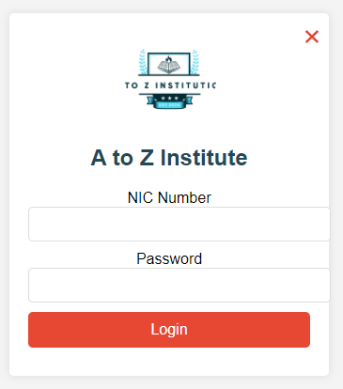

This is the first page for login this login identify the admin and student

Admin nic num :”200417002813” and password is:”admin786”if you type this hard coded password this login automatically load to admin page

2. 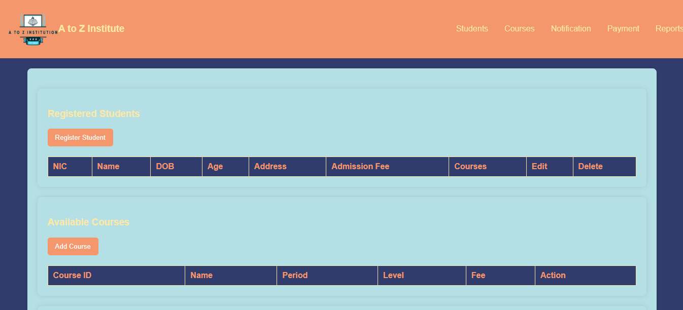

This is the admin page with navbar

This is a fresh software for the institution so here you want to add your corses first. click course on the nevigation bar for show and add courses

3. 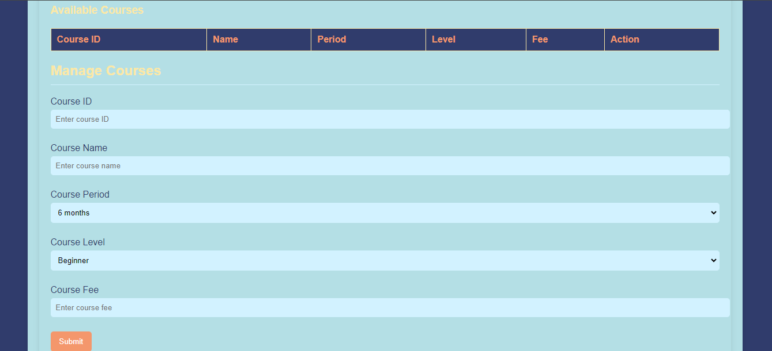

When you adding a course consider that the course id must be unique and no other validations added here

4.

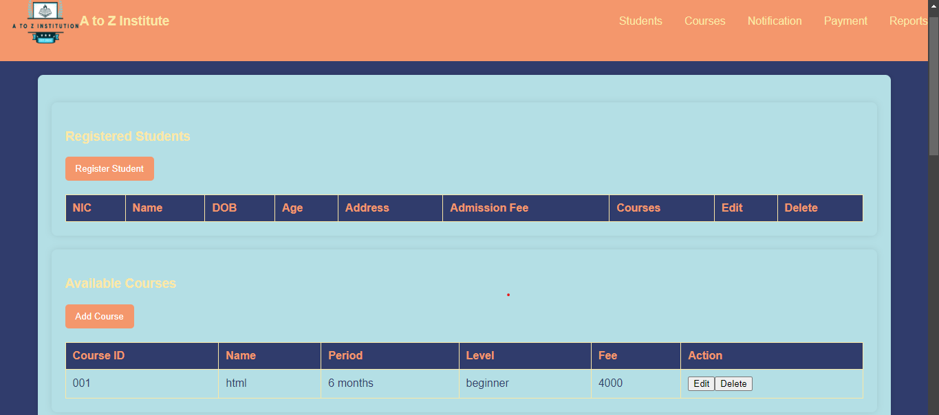

After the adding of courses u can edit and delete the couse

The u can add students for your institution

5.

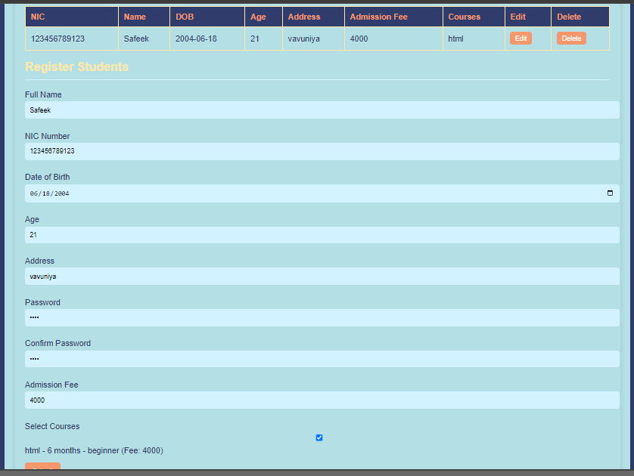

In this section you can add, edit, delete student details

Consider that the nic number and must have 12 characters and it must unique also.

06. after that u can see the payment ,and reports section by refreshing your page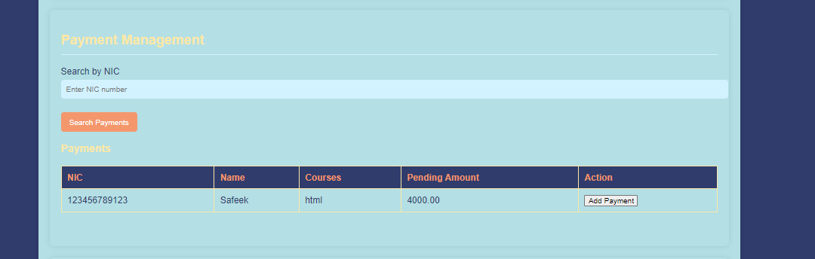

Here you can see the all payment details and separately can view students details by nic num

And u are able to settle payment here

07.

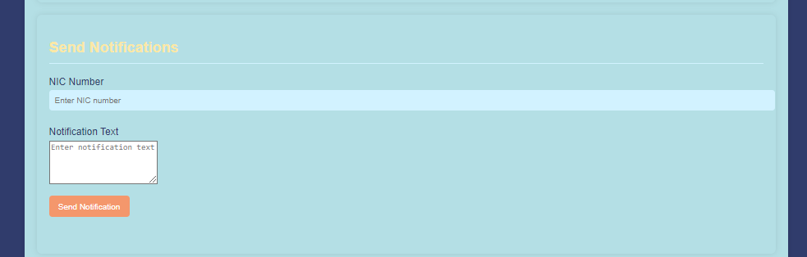

Here u can sent massage by the unique nic num

08.

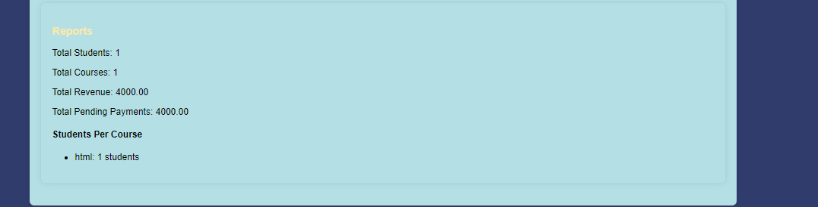

These all for admin page

Next go back to login form as a student



Here you want add registered nic and password it automatically load you to your personal page

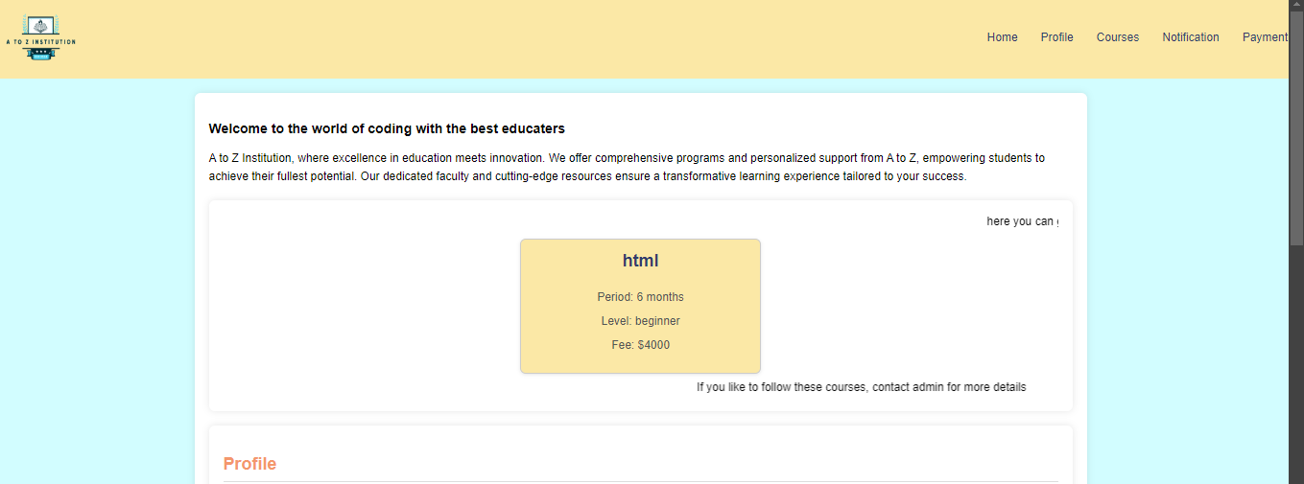

This is the student main page here you have home, profile, courses, notification, payment

In home section courses dynamically loaded by the admin, and you are interested in any course you can contact your administrator for adding courses.

09.in this profile section you can view and edit your details including password

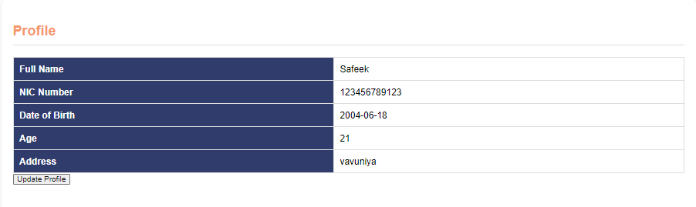

10 . here you can see the course u following

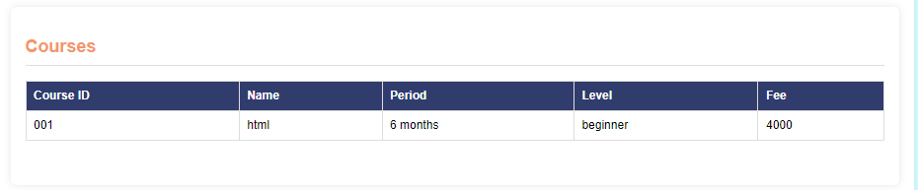

11. 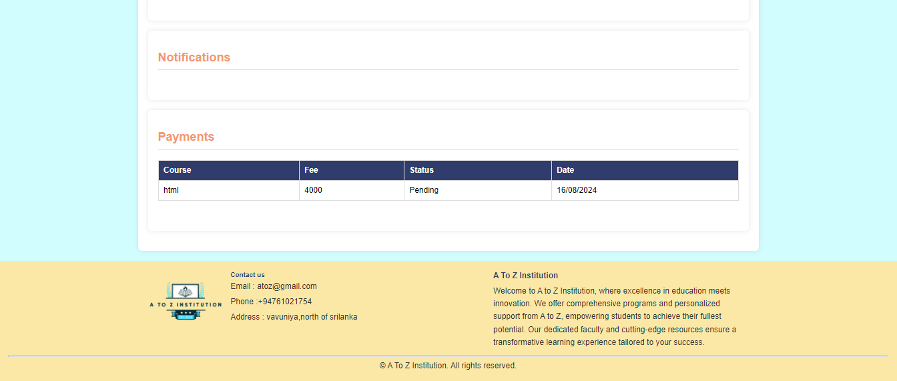

In the notification section you see the notification sanded by admin

In payment you can see your payment details

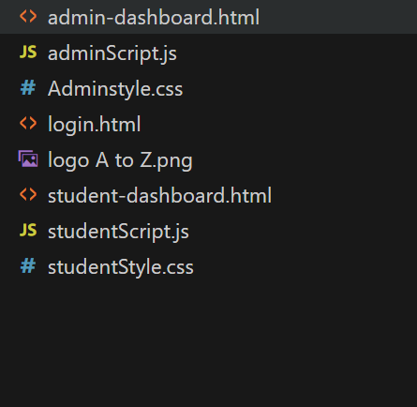

Open folder and click on the html for run code the I think that the login.html page only enough for your test process